CMO.AI – Marketing Strategy Agent Documentation

1. Overview
The Marketing Strategy Agent is a core module within the CMO.AI system, designed to generate data-driven and structured marketing strategies for startups and brand owners.
This agent simulates the role of a Chief Marketing Officer (CMO) by analyzing user inputs and producing actionable marketing plans, including audience targeting, campaign strategies, budget allocation, and performance metrics.

2. Objective
The primary objective of this agent is to:
- Assist users in building effective marketing strategies
- Provide structured, professional, and realistic plans
- Incorporate financial reasoning and data-driven insights
- Serve as a modular component within a larger multi-agent system

3. Input Parameters
The agent collects the following inputs through a user interface:
- Brand Name
- Industry
- Product / Service
- Target Audience
- Marketing Budget
- Marketing Goal (e.g., sales, awareness)
- Selected Marketing Platforms (e.g., Instagram, TikTok) 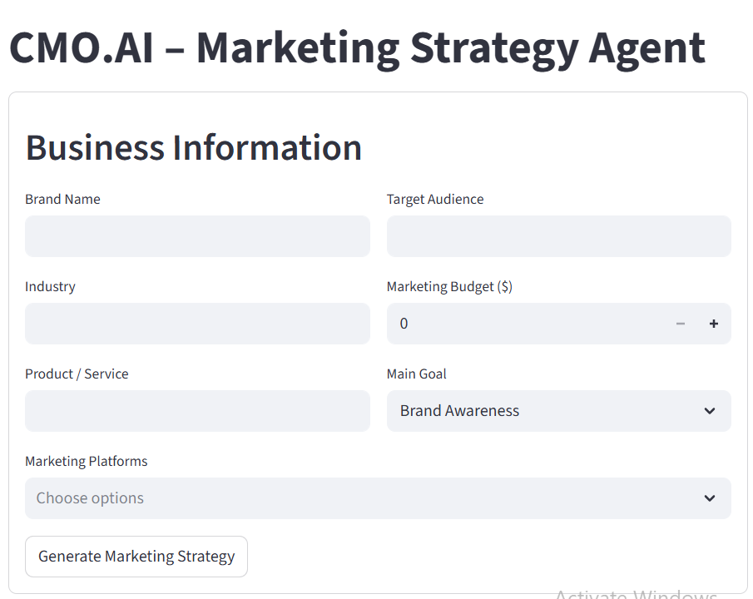

4. System Architecture
The Marketing Strategy Agent follows a hybrid architecture combining rule-based logic and generative AI:

4.1 Components
- User Interface (Streamlit)
  - Collects structured business inputs from the user
- Tool Layer (Deterministic Functions)
  - Budget Allocation Tool
  - Financial Modeling Tool
  - Platform Strategy Tool
  - Decision Logic Module
  - Competitor Insight Generator
- LLM Layer
  - Uses a Large Language Model via Groq API
  - Responsible for generating the final marketing strategy
- Prompt Engineering Layer
  - Structured prompt that guides the model to produce:
    - Audience analysis
    - Content strategy
    - Campaign planning
    - Financial justification
    - KPIs

5. Agent Behavior
Although implemented as a standalone module, the system demonstrates agent-like behavior through:
- Integration of multiple tools (financial, strategic, analytical)
- Context-aware decision logic based on budget
- Data-driven reasoning instead of pure text generation
- Structured and goal-oriented output generation
This makes it a tool-augmented LLM agent, suitable for integration into a multi-agent architecture.

6. Financial Reasoning Module
A key enhancement in this agent is the introduction of a financial modeling component, which calculates:
- Estimated clicks (based on cost-per-click assumptions)
- Conversion rate
- Expected number of sales
- Estimated revenue
- Cost per Acquisition (CPA)
- Return on Ad Spend (ROAS)
This ensures that generated strategies are not purely descriptive, but also quantitatively grounded.

7. Output Structure
The agent generates a complete marketing strategy including:
- Target Audience Analysis
- Positioning & Unique Value Proposition
- Content Strategy
- Campaign Ideas and Execution Plan
- Weekly Posting Schedule
- Budget Allocation and Justification
- Key Performance Indicators (KPIs)
- Expected Financial Outcomes

8. Technologies Used
- Frontend: Streamlit
- Backend Logic: Python
- LLM Integration: Groq API (ChatGroq)
- Framework: LangChain
- Prompt Engineering: ChatPromptTemplate

9. Role in CMO.AI System
This agent represents the Marketing Planner and Strategy Module within the overall CMO.AI architecture.
It will later be integrated with:
- Brand Coaching Agent (input generation)
- Content Generation Agent
- Ads/Image Generation Agent
- Video Generation Agent
- Analytics Agent
Together, these agents will form a complete multi-agent marketing automation system.

10. Model Selection and Justification

10.1 Selected Model
The Marketing Strategy Agent utilizes the ChatGroq LLM with the model: openai/gpt-oss-120b.
This model is accessed through the Groq API, which provides high-speed inference and efficient execution for large-scale language models.

10.2 Why This Model is Suitable
The selection of this model is based on several technical and practical considerations:
• Strong Text Generation
- Produces high-quality, structured marketing strategies
- Maintains professional tone and clear formatting
• Excellent Instruction Following
- Handles multi-step prompts effectively
- Adheres to structured output requirements
- Integrates inputs such as budget, audience, and goals
• Compatible with Tool-Augmented Design
- Works well with external logic (financial model, decision rules)
- Supports explanation and justification of outputs
• High Performance (Groq Infrastructure)
- Low latency (fast responses)
- Efficient handling of long prompts
- Suitable for real-time user interaction

• Cost-Effective for MVP
- Lower cost compared to proprietary models
- No need for fine-tuning
- Ideal for rapid development and testing

11. Conclusion
The Marketing Strategy Agent successfully demonstrates how generative AI combined with structured logic can produce realistic, actionable marketing strategies.
It serves as a foundational component in the development of an intelligent, scalable, and modular AI-powered marketing platform.

